|  |  |
| --- | --- |
|  |  |

***BOMGAR***

**Employee Operation Runbook**

|  |  |
| --- | --- |
| Prepared By : | *Pawan Sharma* |
|  |
| Version Number : | *0.1* |
| Effective Date : | *04/Apr/2018* |

TABLE OF CONTENT

TABLE OF CONTENT 2

Revision History 3

Document Reviewers 4

Document Approvers 4

Document Distribution List 4

How to Find the Latest Version of this Document 4

1. Objective 5

2. Screen sharing options (systems) 5

End Session 6

3. Screen sharing options (iOS) 7

# Revision History

|  |  |  |  |  |
| --- | --- | --- | --- | --- |
| Version Number | Revision Date | Nature of Revision | Revised By | Approval Date |
|  |  |  |  |  |
|  |  |  |  |  |
|  |  |  |  |  |
|  |  |  |  |  |
|  |  |  |  |  |
|  |  |  |  |  |
|  |  |  |  |  |
|  |  |  |  |  |
|  |  |  |  |  |
|  |  |  |  |  |
|  |  |  |  |  |
| **WARNING:**  **Any Hardcopy Printout from this document is an UNCONTROLLED COPY.** | |  | | |

# Document Reviewers

|  |  |  |
| --- | --- | --- |
| **Reviewer Name** | **Reviewer Organization/Department/Role** | **Email contact** |
| *Project Manager* |  |  |
|  |  |  |
|  |  |  |
|  |  |  |

# Document Approvers

|  |  |  |
| --- | --- | --- |
| **Approver Name** | **Approver Organization/Department/Role** | **Email contact** |
|  |  |  |
|  |  |  |
|  |  |  |

# Document Distribution List

|  |  |  |
| --- | --- | --- |
| **Name** | **Organization/Department** | **Email contact** |
|  |  |  |
|  |  |  |
|  |  |  |

# How to Find the Latest Version of this Document

The latest version of this document may be obtained from *<URL For GIPS>*

*.*

# Objective

This Document explains the process from an employee’s machine when a technician is trying to troubleshoot the issue by taking a remote session on employee’s machine.

# Screen sharing options (systems)

The remote support tool being introduced will help support technicians to take a remote session on the employee’s system to perform required troubleshooting.

When an employee calls the service desk and the support representative find the remote session is required, s/he will either advice the employee to open the page ‘https://remotesupport.pg.com’ and provide a 7 digit session key or a link will be sent on email/livestation chat. The employee reach the page to start the session and will be required to download and run a small piece of software to initiate the session. Once the session is started, employee will get a session window as shown below:

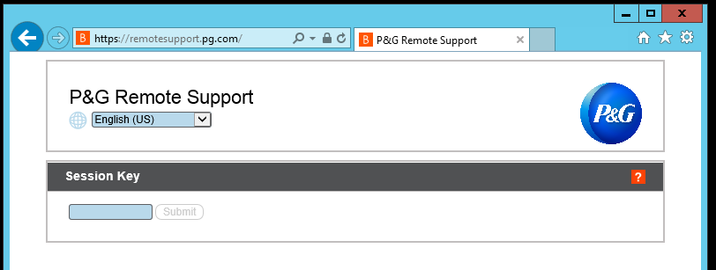

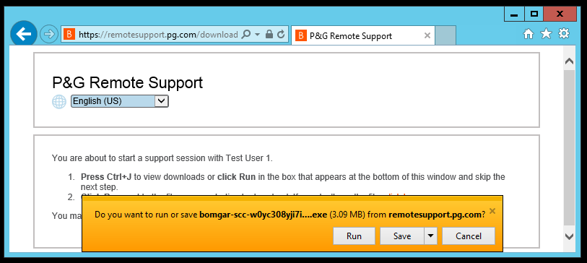

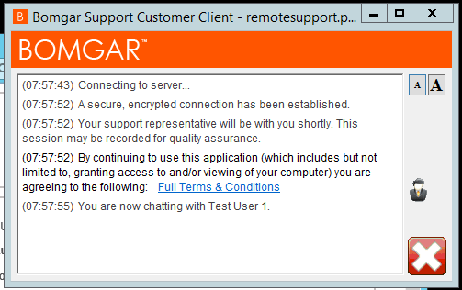

This window will show the name of the agent who has initiated the session. Now the support technician can start a remote control they will initiate the same from their end. Employee will get the following prompt to provide permission to initiate the remote support on the system.

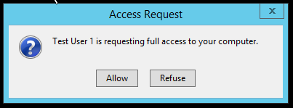

Once employee allows the remote session, the technician can perform the required troubleshooting.

## End Session

Employee can click on the cross button (Shown in the picture below) on the bottom right corner of client window to end the session any time.

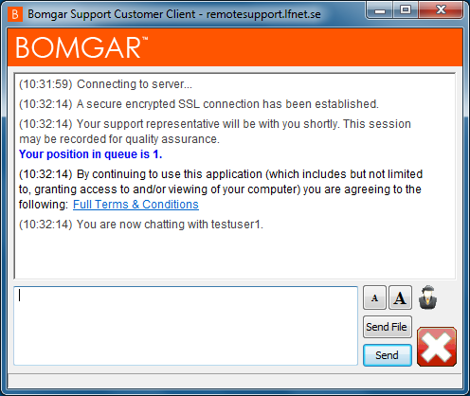

# Screen sharing options (iOS)

Beginning with iOS version 11, iOS mobile devices can share or broadcast their screen to other applications. However, before an employee can start screen sharing from their iOS device, they must configure their device to use this functionality.

* From the iOS device, go to Settings > Control Centre.

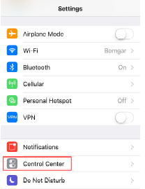

* Tap Customize Controls.

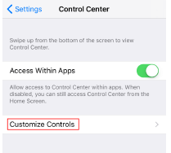

* Scroll down to the More Controls section and tap + by the Screen Recording option. Screen Recording will then appear under the Include section. At this point, the iOS device can begin broadcasting its screen to other applications.

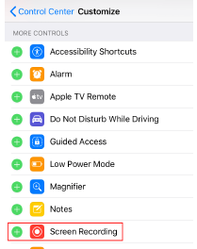

To start the session, agent will request employee to download and install the ‘Bomgar Remote Support Customer Client’ either from app store or the same would already had been pushed to the system.

* Open the Bomgar Remote Support Customer Client app on the iOS device.
* Enter the site name (https://remotesupport.pg.com) and session key provided by the representative. Tap Submit.
* Once the representative accepts the session, the session dialog appears.

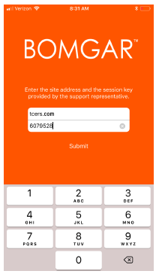

* While in the customer client, starting at the bottom of the screen, swipe up to reveal more iOS options.
* Firmly press the Screen Recording icon.
* From the Screen Recording prompt, tap Bomgar Support.

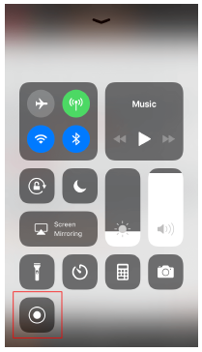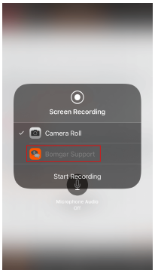

* Then tap Start Broadcast. A countdown appears, indicating when broadcasting will begin.

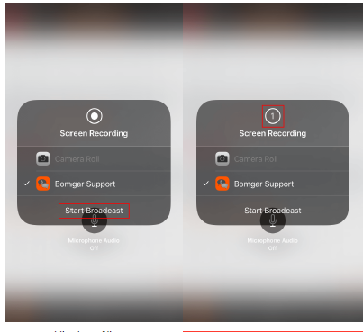

* Once screen sharing is in progress, a thin red bar appears at the top of the screen. As long as the red bar is present, screen sharing is in progress and the agent can continue providing the required support to the employee

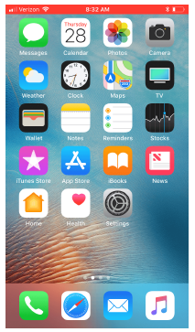

* Once screen sharing is in progress, a thin red bar appears at the top of the screen. As long as the red bar is present, screen sharing is in progress.

